St Anthony’s Catholic Primary School  Child Protection and Safeguarding  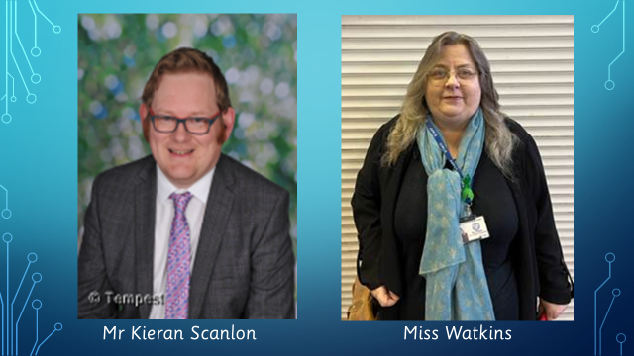  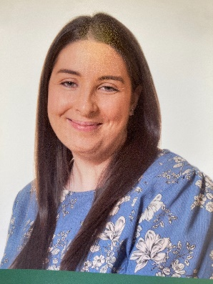  Mrs Potter  The school has a Designated Safeguarding Lead, Mr Scanlon and two Deputy Safeguarding Leads: Miss Watkins and Mrs Potter who are fully trained in safeguarding procedures. Miss Watkins leads on the day-to-day child protection duties in school, such as listening to children’s concerns and liaising with parents, children’s services such as Solihull Multi Agency Safeguarding Hub (MASH) and police.  WHAT PARENTS/CARERS MUST DO  Parents are individuals that hold parental responsibility. A mother automatically has parental responsibility for her child from birth. A father usually has parental responsibility if he’s either:  - married to the child’s mother  - listed on the birth certificate (after a certain date, depending on which part of the UK the child was born in)  Parents are the most important people to keep their children safe. You should always:  - Feel confident to raise concerns about your child.  - Talk to school if you need help or support.  - Read the school policies about safeguarding issues (available on the school website).  - Let the school know if your child has a medical condition.  - Let the school know if you have any court orders relating to the safety of your child.  - Let the school know if there is a change in your circumstances such as: a house move, a new contact number, a change of name or a change of parental responsibility.  - Let us know who will be dropping off or collecting your child.  - Provide two emergency contacts.  - Inform the school of any changes to agreed arrangements.  - Let the school know if your child is going to be absent and the reason why. (0121 770 3168) |  | WHAT SCHOOL MUST DO  A child should be able to go to school and feel safe so that they can achieve their very best.  Everybody who works or volunteers at St Anthony’s will have a Disclosure and Barring Service (DBS) check to make sure they are safe to work with children and they are trained to identify child abuse and what to do if they are concerned.  We will always listen to you and work closely with you if we are concerned about your child but, in some circumstances, we may not be able to discuss our concern with you. The school has a Child Protection and Safeguarding policy which tells you more about this and when we must speak to the police or children’s services directly. You can see this policy on the school website.  When school staff are advised by agencies such as children’s services or police not to talk to parents, we always follow this advice. |  | Child Protection  All staff receive regular child protection and safeguarding training. We work with parents where possible but also have a legal duty to involve other agencies to keep children safe from harm.  Harm is identified broadly as:  Physical—This is when a child is deliberately hurt or injured.  Sexual—This is when a child is influenced or forced to take part in a sexual activity. This can be a physical activity or none physical, e.g. being made to look at an inappropriate image.  Emotional—this is when a child is made to feel frightened, worthless or unloved. It can be shouting, using threats or making fun of someone. It can also be when children see their parents or visitors to the home, fighting or using violence. Where children live in a home where there is cohesion and control by a parent.  School receive Operation Encompass alerts from Children’s Services if there has been a police call out to a home due to a domestic violence incident and there is a school aged child present, whether the child was involved or not.  Neglect—This is when a child is not being taken care of by their parents. It can be poor hygiene, poor diet, not keeping appointments for additional support, not attending school or being left at home alone or not being supervised.  Referral outcomes  Some referrals result in no further action as the disclosure from the child is explored further with the family and no harm is evident.  Some referrals will result in a social work assessment so children’s services can explore if the family need additional support.  Some referrals will result in a child protection conference where parents, school staff and other professionals meet to discuss concerns. If the threshold of significant harm is met, the child will be placed on a ‘child protection’ plan and the family and professionals along with school staff will work together to reduce the risk of harm; or the family might be supported under a ‘child in need’ plan; or it might be decided that no further action is needed.  Helpful Contacts  Solihull MASH 0121 7884300  The National Society for the Prevention of Cruelty to Children (NSPCC) helpline (0808 800 5000),  Childline (0800 1111)  https://learning.nspcc.org.uk/research-resources/leaflets/parent-leaflets  https://www.solihull.gov.uk/children-and-family-support/parenting-support  Family Helpline-Early Help Support -0121 7884327
Making a referral to children’s services
If a child makes a child protection disclosure at school school will contact Solihull MASH and ask advice. If school staff are advised to make a referral into children’s services staff will seek advice as to whether information can be shared with parents. Where possible school staff, usually Miss Watkins, will contact parents and explain that their child has made a disclosure which needs to be referred to children’s services. We recognise that this phone call or meeting may come as a huge shock to parents and may cause a high level of stress. Staff will seek permission to make the referral from parents but if permission is not given a referral will still be made to prevent harm to a child.
If the referral can be shared with parents, permission is sought so that parents can be aware that they will be contacted by a social worker or other agency.
School staff should believe children and it is not the role of school staff to investigate a child protection disclosure, which is why a referal is made to children’s services.
Staff will always follow policy and prodedures as sensitively as possible but always put the child’s needs first.

Mr Cieran Flaherty
Executive Head

