St Anthony’s Catholic Primary School

Anti-Bullying Policy


Key Contact Personnel

Designated Safeguarding Lead (s):
Mr Kieran Scanlon-Head of School
Miss Karen Watkins-Family Support and Safeguarding
Mrs Anna Potter-Assistant Head

Date written: September 2025
Date of next review: September 2026

This policy will be reviewed at least annually, and following any concerns and/or updates to national/local guidance or procedures

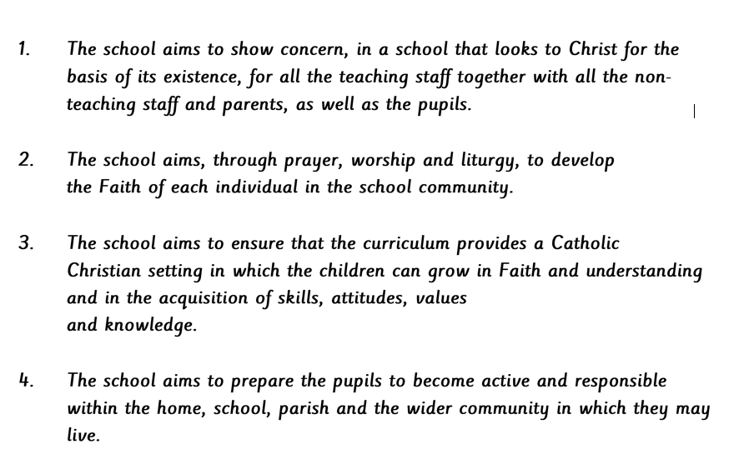
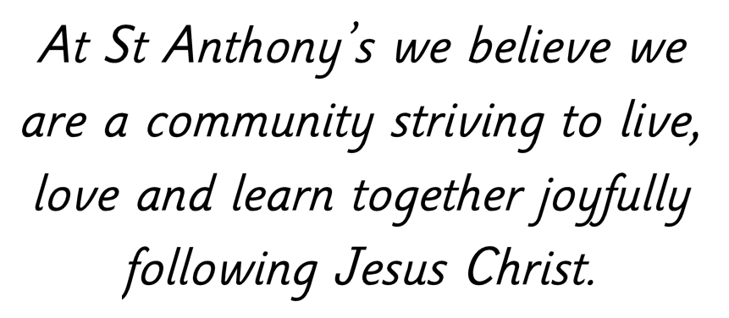

Anti-Bullying Policy
This policy is based on DfE guidance “Preventing and Tackling Bullying” July 2017 and supporting documents. It also considers the DfE statutory guidance “Keeping Children Safe in Education” and “Sexual violence and sexual harassment between children in schools and colleges” guidance.

1) Policy Objectives
- This policy outlines what St Anthony’s Primary School will do to prevent and tackle all forms of bullying.
- The policy has been adopted with the involvement of the whole school community.
- St Anthony’s Primary School is committed to developing an anti-bullying culture where the bullying of adults, children or young people is not tolerated in any form.

2) Links with Other School Policies and Practices
• This policy links with several school policies, practices and action plans including:
o Behaviour and discipline policy o Complaints policy o Child Protection policy o Confidentiality policy o Acceptable Use Policies (AUP) o Curriculum policies, such as, RSE/RSHE, PSHE, citizenship and computing o Online Safety (including mobile and smart technology and social media) policy o Searching, screening and confiscation policy.

3) Links to Legislation
• There are several pieces of legislation which set out measures and actions for schools in response to bullying, as well as criminal and civil law. These may include (but are not limited to):
o The Education and Inspection Act 2006, 2011 o The Equality Act 2010 o The Children Act 1989 o Protection from Harassment Act 1997 o The Malicious Communications Act 1988 o Public Order Act 1986.

4) Responsibilities

• It is the responsibility of:
- The head of school to communicate this policy to the school community, to ensure that disciplinary measures are applied fairly, consistently and reasonably, and that a member of the senior leadership team has been identified to take overall responsibility. o Governors to take a lead role in monitoring and reviewing this policy.
- All staff, including governors, senior leadership, teaching and non-teaching staff, to support, uphold and implement this policy accordingly.
- Parents/carers to support their children and work in partnership with the school.
- Pupils to abide by the policy.

5) Definition of Bullying
- Bullying can be defined as ‘behaviour by an individual or a group, repeated over time that intentionally hurts another individual either physically or emotionally’. DfE ‘Preventing and Tackling Bullying
- Bullying can include physical and emotional abuse such as name calling, taunting, mocking, making offensive comments, kicking, hitting, taking belongings, producing offensive graffiti, gossiping, peer isolation (e.g. excluding people from groups) and spreading hurtful and untruthful rumours.
- The same unacceptable behaviours can be expressed online; this is sometimes called online bullying or cyberbullying. Specifically, this can include sending offensive, upsetting and inappropriate messages by phone, text, instant messenger, through gaming, websites, social media sites and apps, and sending offensive or degrading photos or videos.
- St Anthony’s Primary School recognise that bullying can be emotionally abusive and can cause severe and adverse effects on children’s emotional development.
- Bullying is recognised by St Anthony’s Primary School as being a form of child on child abuse; children can abuse other children.
  - Abuse is abuse and it should never be tolerated or passed off as “banter”, “just having a laugh” or “part of growing up”.
  - We recognise that even if there are no reports of bullying, it does not mean it is not happening and it may be the case that it is just not being reported.
  - All victims will be taken seriously and offered appropriate support, regardless of where the abuse takes place.

6) Forms and Types of Bullying Covered by this Policy
• Bullying can happen to anyone. This policy covers all types and forms of bullying including but not limited to:
- Bullying related to physical appearance
- Bullying of young carers, children in care or otherwise related to home circumstances
- Bullying related to physical/mental health conditions
- o Physical bullying o Emotional bullying
- Sexualised bullying/harassment
- o Bullying via technology, known as online bullying or cyberbullying
- o Prejudiced-based and discriminatory bullying (against people/pupils with protected characteristics) which may include:
  - Bullying related to race, religion, faith and belief and for those without faith
  - Bullying related to ethnicity, nationality or culture
  - Bullying related to Special Educational Needs or Disability (SEND)
  - Bullying related to sexual orientation
  - Gender based bullying

7) School Ethos
- St Anthony’s Primary School community recognises that all forms of bullying, especially if left unaddressed, can have a devastating effect on individuals; it can create a barrier to learning and have serious consequences for mental wellbeing.
- By effectively preventing and tackling bullying our school can help to create a safe and disciplined environment, where pupils are able to learn and fulfil their potential.

- Our Community: o Understands the importance of challenging inappropriate behaviours between peers. o Monitors and reviews our anti-bullying policy and practice on a regular basis. o Supports staff to promote positive relationships to help prevent bullying.
  - Recognises that some members of our community may be more vulnerable to bullying and its impact than others; this may include children with SEND. Being aware of this will help us to develop effective strategies to prevent bullying from happening and provide appropriate support, if required.
  - Will intervene by identifying and tackling bullying behaviour appropriately and promptly.
  - Ensures our pupils are aware that bullying concerns will be dealt with sensitively and effectively; that everyone should feel safe to learn and abide by the anti-bullying policy.
  - Requires all members of the community to work with the school to uphold the ant bullying policy.
  - Recognises the potential impact of bullying on the wider family of those affected so will work in partnership with parents/carers regarding all reported bullying concerns and will seek to keep them informed at all stages.
  - Will deal promptly with grievances regarding the school response to bullying in line with our complaints policy.
  - Seeks to learn from good anti-bullying practice elsewhere. o Utilises support from the Local Authority and other relevant organisations when appropriate.

8) Responding to Bullying Concerns
• The following steps will be taken when dealing with any incidents of bullying reported to the school: o If bullying is suspected or reported, the incident will be dealt with immediately by the member of staff who has been approached or witnessed the concern.
- The school will provide appropriate support for the person being bullied – making sure they are not at risk of immediate harm and will involve them in any decision-making, as appropriate.
- The DSL will be informed of all bullying concerns, especially where there may be safeguarding issues.
- The head of School, or another appropriate member of staff will interview all parties involved.
- A clear and precise account of bullying incidents will be recorded by the school in accordance with existing procedures. This will include recording appropriate details regarding decisions and action taken.
- The school will speak with and inform other staff members, where appropriate.
- The school will ensure parents/carers are kept informed about the concern and action taken, as appropriate and in line with child protection and confidentially policies.
- Appropriate sanctions and support, for example as identified within the school behaviour policy and child protection policy, will be implemented in consultation with all parties concerned.
- If necessary, other agencies may be consulted or involved, for example the police if a criminal offence has been committed, or Integrated Children Services or Early Help if a child is felt to be at risk of significant harm.
- Where the bullying of or by pupils takes place off school site or outside of normal school hours (including cyberbullying), the school will explore and advise in line with our Online Safety Policy and the school behaviour policy. If required, the DSL will collaborate with DSLs at other settings.

Cyberbullying

• When responding to cyberbullying concerns, the school will:
- Act as soon as an incident has been reported or identified. o Provide appropriate support for the person who has been cyberbullied, and work with the person who has carried out the bullying to ensure that it does not happen again.
- Encourage the person being bullied to keep any evidence (screenshots) of the bullying activity to assist any investigation.
- Work with the individuals and online service providers to prevent the incident from spreading and assist in removing offensive or upsetting material from circulation. This may include:
  - Support reports to a service provider to remove content if those involved are unable to be identified or if those involved refuse to or are unable to delete content.
  - Confiscating and searching pupils’ electronic devices, such as mobile phones, in accordance with the law and the school searching and confiscation policy. (We will access the DfE ‘Searching, screening and confiscation at school’ and Childnet cyberbullying guidance to ensure that the school’s powers are used proportionately and lawfully).
  - Requesting the deletion of locally-held content and content posted online if they contravene school behavioural policies.
- Where an individual can be identified, the school will ensure that appropriate sanctions are implemented to change the attitude and behaviour of the bully, as well as ensuring access to any additional help or support they may need.
- Inform the police if a criminal offence has been committed. o Provide information to staff and pupils regarding steps they can take to protect themselves online. This may include:
  - advising those targeted not to retaliate or reply.
  - providing advice on blocking or removing people from contact lists.
  - helping those involved to consider and manage any private information they may have in the public domain.

Supporting Pupils
- Pupils who have been bullied will be supported by:
  - Reassuring the pupil and providing immediate pastoral support. o Offering an immediate opportunity to discuss the experience with their teacher, the DSL, or a member of staff of their choice. o Being advised to keep a record of the bullying on a Bully Log as evidence and discuss how to respond to any further concerns.
  - Working towards restoring self-esteem and confidence.
  - Providing ongoing support. This may include working and speaking with staff, engaging with parents and carers. o Where necessary, working with the wider community and local/national organisations to provide further or specialist advice and guidance; this could include support through Early Help or Integrated Children Services or support through the Children and Young People's Mental Health Service (SOLAR).

- Pupils who have perpetrated bullying will be helped by:
  - Discussing what happened, establishing the concern and the need to change. o Informing parents/carers to help change the attitude and behaviour of the child. o Providing appropriate education and support regarding their behaviour or actions.
  - Sanctioning, in line with school behaviour/discipline policy. This may include:
    - official warnings
    - detentions/internal exclusions
    - removal of privileges (including online access when encountering cyberbullying concerns)
    - in extreme or repeated cases, fixed-term or permanent exclusions. o Where necessary, working with the wider community and local/national organisations to provide further or specialist advice and guidance; this may include involvement from the Police or referrals to Integrated Children Services or Early Help or support through the Children and Young People's Mental Health Service (SOLAR).

Supporting Adults
- Our school takes measures to prevent and tackle bullying among pupils; however, it is equally important to recognise that bullying of adults, including staff and parents, whether by pupils, parents or other staff members, is unacceptable.

- Adults who have been bullied or affected will be supported by:
  - Offering an immediate opportunity to discuss the concern with the designated safeguarding lead, a senior member of staff and/or the head of School.
  - Advising them to keep a record of the bullying as evidence and discuss how to respond to future concerns.
  - Where the bullying takes place off school site or outside of normal school hours (including online), the school will still investigate the concern and ensure that appropriate action is taken in accordance with the schools’ behaviour and discipline policy.
  - Encouraging the reporting of offensive or upsetting content and/or accounts to the service provider, where the bullying has occurred online.
  - Reassuring and offering appropriate support.
  - Working with the wider community and local/national organisations to provide further or specialist advice and guidance.

- Adults who have perpetrated the bullying will be helped by:
    - Discussing what happened with a senior member of staff and/or the head of school to establish the concern.
    - Establishing whether a legitimate grievance or concern has been raised and signposting to the school’s official complaints procedures.
    - If online, requesting that content be removed.
    - Instigating disciplinary, civil or legal action as appropriate or required.

9) Preventing Bullying

Environment
• The whole school community will:
- Create and support an inclusive environment which promotes a culture of mutual respect, consideration and care for others, which will be upheld by all. o Recognise that bullying can be perpetrated or experienced by any member of the community, including adults and children (child on child abuse).
- Recognise the potential for children with Special Educational Needs and Disabilities (SEND) to be disproportionally impacted by bullying and will implement additional pastoral support as required. o Recognise that bullying may be affected and influenced by gender, age, ability and culture of those involved.
- Openly discuss differences between people that could motivate bullying, such as: children with different family situations, such as looked after children or those with caring responsibilities, religion, ethnicity, disability, gender, sexuality or appearance related difference.
- Challenge practice and language (including ‘banter’) which does not uphold the school values of tolerance, non-discrimination and respect towards others.
- Be encouraged to use technology, especially mobile phones and social media, positively and responsibly.
- Work with staff, the wider community and outside agencies to prevent and tackle concerns including all forms of prejudice-based and discriminatory bullying.
- Actively create “safe spaces” for vulnerable children and young people.
- Celebrate success and achievements to promote and build a positive school ethos.

Policy and Support
• The whole school community will:
- Provide a range of approaches for pupils, staff and parents/carers to access support and report concerns.
- Regularly update and evaluate our practice to consider the developments of technology and provide up-to-date advice and education to all members of the community regarding positive online behaviour.
- Take appropriate, proportionate and reasonable action, in line with existing school policies, for any bullying bought to the schools’ attention, which involves or effects pupils.
- Implement appropriate disciplinary sanctions; the consequences of bullying will reflect the seriousness of the incident, so that others see that bullying is unacceptable.
- Use a variety of techniques to resolve the issues between those who bully, and those who have been bullied.

Education and Training
• The school community will:
- Train all staff, including teaching staff, support staff and pastoral staff, to identify all forms of bullying and take appropriate action, following the school’s policy and procedures, including recording and reporting incidents.
- Consider a range of opportunities and approaches for addressing bullying throughout the curriculum and other activities, such as: through displays, assemblies, peer support, the school/student council, etc.
- Collaborate with other local educational settings as appropriate, and during key times of the year, for example during transition. o Ensure anti-bullying has a high profile throughout the year, reinforced through key opportunities such as anti-bullying week
- Provide systematic opportunities to develop pupils’ social and emotional skills, including building self-esteem.

10) Involvement of Pupils
• We will:
- Help pupils to ensure that they understand the school’s approach and are clear about the part they play in preventing bullying. o Regularly canvas pupils’ views on the extent and nature of bullying. o Ensure that all pupils know how to express worries and anxieties about bullying. o Ensure that all pupils are aware of the range of sanctions which may be applied against those engaging in bullying. o Involve pupils in anti-bullying campaigns in schools and embedded messages in the wider school curriculum.
- Utilise pupil voice in providing pupil led education and support o Publicise the details of internal support, as well as external helplines and websites.
- Offer support to pupils who have been bullied and to those who are bullying to address the problems they have.

11) Involvement and Liaison with Parents and Carers
• We will:
- Take steps to involve parents and carers in develop policies and procedures, to ensure they are aware that the school does not tolerate any form of bullying.
- Make sure that key information about prejudice-based and discriminatory bullying (including policies and named points of contact) is available to parents/carers in a variety of formats, including via the school website.
- Ensure all parents/carers know who to contact if they are worried about bullying and where to access independent advice. o Work with all parents/carers and the local community to address issues beyond the school gates that give rise to bullying.
- Ensure that parents work with the school to role model positive behaviour for pupils, both on and offline.
- Ensure all parents/carers know about our complaints procedure and how to use it effectively, to raise concerns in an appropriate manner.

12) Monitoring and Review: Putting Policy into Practice
- The school will ensure that they regularly monitor and evaluate mechanisms to ensure that the policy is being consistently applied.
- Any issues identified will be incorporated into the school’s action planning.
- The head of school will be informed of bullying concerns, as appropriate via CPOMS or in person.
- The named Governor for bullying will report on a regular basis to the governing body on incidents of bullying, including outcomes.

13) Useful Links and Supporting Organisations
The following links may provide additional support to children, staff or families.
- Anti-Bullying Alliance: www.anti-bullyingalliance.org.uk
- Childline: www.childline.org.uk
- Family Lives: www.familylives.org.uk
- Kidscape: www.kidscape.org.uk
- MindEd: www.minded.org.uk
- NSPCC: www.nspcc.org.uk
- PSHE Association: www.pshe-association.org.uk
- Restorative Justice Council: www.restorativejustice.org.uk
- The Diana Award: www.diana-award.org.uk
- Victim Support: www.victimsupport.org.uk
- Young Minds: www.youngminds.org.uk
- Young Carers: www.youngcarers.net

Cyberbullying
- Childnet: www.childnet.com
- Internet Watch Foundation: www.iwf.org.uk
- Report Harmful Content: https://reportharmfulcontent.com/
- UK Safer Internet Centre: www.saferinternet.org.uk
- The UK Council for Internet Safety (UKCIS): www.gov.uk/government/organisations/ukcouncil-for-internet-safety
- DfE ‘Cyberbullying: advice for headteachers and school staff’:
www.gov.uk/government/publications/preventing-and-tackling-bullying
- DfE ‘Advice for parents and carers on cyberbullying’:
www.gov.uk/government/publications/preventing-and-tackling-bullying

SEND
- Changing Faces: www.changingfaces.org.uk
- Mencap: www.mencap.org.uk
- Anti-Bullying Alliance Cyberbullying and children and young people with SEN and disabilities: www.anti-bullyingalliance.org.uk/tools-information/all-about-bullying/atrisk-groups/sen-disability
- DfE: SEND code of practice: www.gov.uk/government/publications/send-code-of-practice-0to-25

Race, Religion and Nationality
- Anne Frank Trust: www.annefrank.org.uk
- Kick it Out: www.kickitout.org
- Report it: www.report-it.org.uk
- Stop Hate: www.stophateuk.org
- Tell Mama: www.tellmamauk.org
- Educate against Hate: www.educateagainsthate.com
- Show Racism the Red Card: www.srtrc.org/educational

LGBTQ+
- Barnardo’s LGBTQ Hub: www.barnardos.org.uk/what_we_do/our_work/lgbtq.htm
- Metro Charity: www.metrocentreonline.org
- EACH: www.eachaction.org.uk
- Proud Trust: www.theproudtrust.org
- Schools Out: www.schools-out.org.uk
- Stonewall: www.stonewall.org.uk

Sexual Harassment and Sexual Bullying
- NSPCC ‘Report Abuse in Education’ Helpline: 0800 136 663 or help@nspcc.org.uk
- Ending Violence Against Women and Girls (EVAW): www.endviolenceagainstwomen.org.uk
- Disrespect No Body: www.gov.uk/government/publications/disrespect-nobody-campaignposters
- Anti-bullying Alliance: Preventing and responding to Sexual Bullying: www.antibullyingalliance.org.uk/tools-information/all-about-bullying/sexual-and-sexist-bullying
- Anti-bullying Alliance: advice for school staff and professionals about developing effective anti-bullying practice in relation to sexual bullying: https://anti-bullyingalliance.org.uk/toolsinformation/all-about-bullying/sexual-and-sexist-bullying/investigating-and-respondingsexual
- Childnet Project DeShame (Online Sexual Harassment and Bullying): www.childnet.com/our-projects/project-deshame

