

BEHAVIOUR
POLICY

Date written: September 2025
Date of next review: September 2026

Behaviour Policy - Updated Sep 25 1

Introduction

The Governing Body is responsible for setting the framework of the school’s Behaviour Policy through a written statement of general principles, taking into account the needs of all pupils, including any with educational special needs under the Equality Act 2010. The statement should cover such areas as ethos of the school, its moral code, positive and constructive rules of conduct and the rewards and sanctions which the school will use.

This policy is to be shared with parents, new staff, teachers, support staff and others working within the school. To meet statutory legislation, a school’s policy on behaviour must be reviewed each year. This is done at the start of the autumn term.

This policy recognises that it has a part to play in the spiritual, moral, social and cultural development of children and that Personal Social Heath Education is an important element in a pupil’s education.

Ethos

At St Anthony’s we value each child’s individuality and ability and aim to create a positive, welcoming environment, where good behaviour is rewarded and unacceptable behaviour discouraged.

We believe that good behaviour is an essential condition for effective teaching and learning to take place and that pupils and staff have the right to learn and teach in a secure environment that promotes and supports good behaviour. Through the example of the adults who care for them at school and through well planned and stimulating learning opportunities, we believe that children will accept learning challenges, increase their self-discipline and develop greater responsibility for their own actions. We also believe that it is the responsibility of parents to share with the school in helping their children to behave well.

The children were consulted on what good behaviour means and they formulated the following definition:

“We believe that good behaviour means that everyone in school is kind, caring helpful and friendly towards one another. It means showing respect towards everyone and using our manners all of the time. Good behaviour means being willing and able to listen to each other and remembering to share and co-operate all of the time. It means doing our best in everything we do and believing we can succeed. It means saying sorry if we do something wrong.”

Aims of this policy

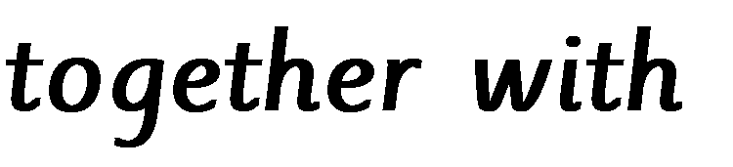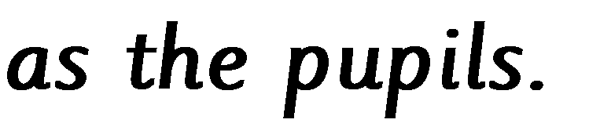

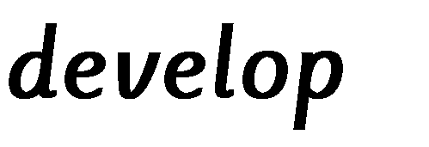
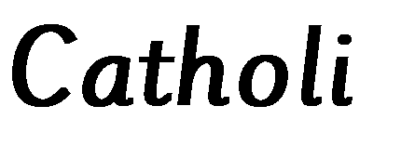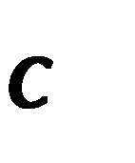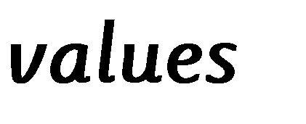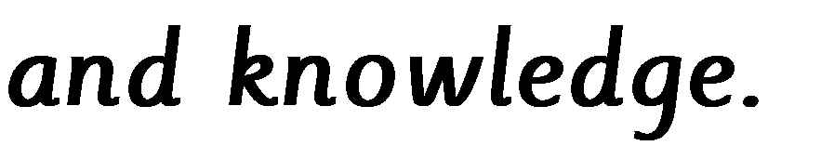

- To create an environment that encourages and reinforces good behaviour
- To work consistently and fairly in the positive management of behaviour
- To appreciate and follow an agreed code of behaviour
- To encourage children to treat each other, staff and visitors to the school with care, consideration and respect
- To encourage children to value good behaviour, develop self-discipline and take responsibility for the consequences of their own actions

- To provide a stimulating and appropriate curriculum that promotes a sense of individual and collective worth and achievement
- In partnership with parents/carers, to assist children in distinguishing between right and wrong and in becoming aware of their rights and responsibilities and the rights and responsibilities of others

Roles and Responsibilities

The Role of the Head of School
It is the role of the Head of school to implement and monitor the school Behaviour Policy consistently throughout the school, and to report to Governors, when requested, on the effectiveness of the policy. It is also the responsibility of the Head of school to ensure the health, safety and welfare of all the children in the school.

The role of staff

- To fully comply with the school policies and procedures
•To inform the Head of school of any concerns and follow the line management system/school procedures for reporting concerns.
- To treat all pupils and the school community fairly and with respect.
- To maintain high expectations of pupil behaviour and learning.
- To reinforce expectations of behaviour consistently through rewards and sanctions.
- To be a good role model for behaviour.
- To establish effective partnerships with parents so that pupils can see the key adults in their lives share a common aim.
- To recognise and address the individual needs of all pupils.
- To acknowledge, celebrate and reward all positive achievements and behaviours

The Role of the Governors
The Governing Body must ensure that policies designed to promote good behaviour and discipline on the part of its pupils are pursued at the school and support the staff in its implementation.
The Governing Body will monitor the effectiveness of the Behaviour Policy in bringing about its stated aims and objectives.

The role of the children

- To work to the best of their abilities to allow others to do the same.
- To treat others with respect at all times.
- To be good role models for other pupils.
- To respond appropriately to the instructions of staff and other adults working in the school.
- To take care of property and the environment in and around the school.
- To cooperate with pupil and adults in all aspects of school life.
- To help formulate and comply with classroom rules.
- To move sensibly and quietly around the school.
- To share in celebrating the achievements of all members of the school community.

The role of parents

We aim to foster close links with parents and encourage their involvement in the school. Our ‘open door’ policy facilitates good communication and an awareness of the standards and expectations of our school.

We expect parents to:
- Work in partnership with us to encourage respect, hard work and good behaviour.
- Support the school’s Behaviour Policy
- To ensure pupils attend school regularly and arrive on time.
- To inform school staff about anything that may affect pupil’s work, behaviour and well-being at school.
- To offer help and support with learning at home, including the completion of homework.

Whole school strategies

Equal opportunities and inclusion

At St Anthony’s Primary, all children are treated with equal respect and fairness. All children will be made aware of the school expectations of behaviour and the consequences of not following them. Awareness is needed of children who might have particular needs and approaches, but there are no variations in expectations.

Learning and teaching

A positive classroom ethos with good relationships between staff and pupils can have a significant impact on the behaviour in school. Our staff undertake to plan a well-structured curriculum that meets the needs of individual children and actively involves them in their learning. High expectations are constantly reinforced and structured feedback and meaningful praise encourage good behaviour.

Our staff aim to maximise opportunities in the curriculum to foster and discuss aspects of behaviour. Particular opportunities lie within the PSHE curriculum but we also use “circle time” to develop social skills when appropriate. Assemblies also provide an opportunity for highlighting behaviour in school, appropriate or otherwise, and we celebrate good work and achievements on a weekly basis.

Environment

It is the shared responsibility of staff and pupils to take a pride in our school environment. We aim to ensure our accommodation is clean, bright and well maintained. The classrooms are welcoming, stimulating and well organised so that they are conducive to learning. All staff act as role models and encourage good practices, keeping the school clean, tidy and litter free. They also model positive ways to interact with others, such as in the ways they address and respond to each other and children. Likewise, parents and other people working with the children should foster a caring attitude, encouraging respect and care for personal belongings, bags, PE kit etc.

Rules, Procedures and the Behaviour Curriculum

Rules and procedures should support children in achieving expected standards of behaviour. They should be positive, telling the children what they should do rather than what not to do and be consistently and fairly applied

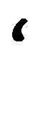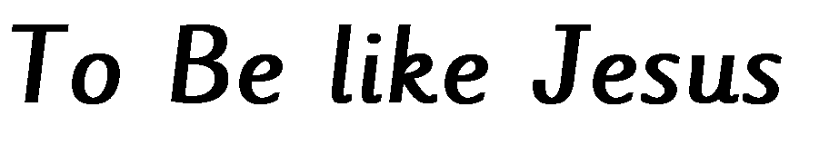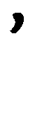
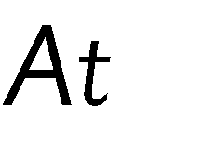
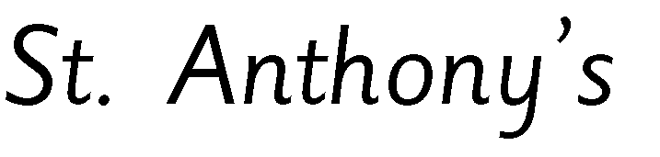
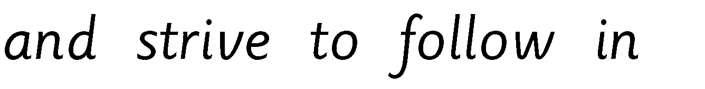
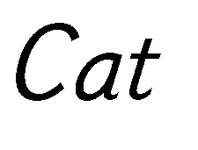
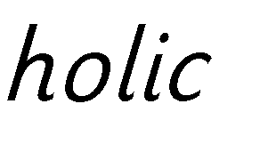
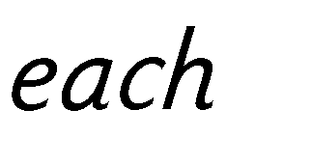
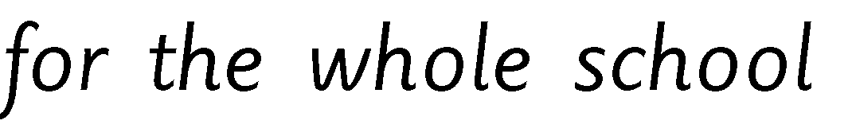
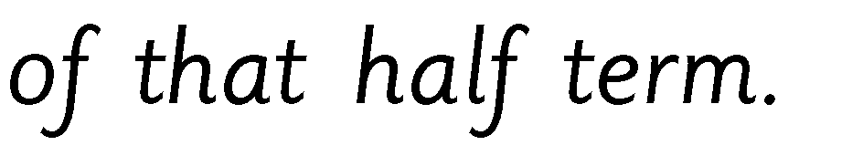

This behaviour is encouraged in every aspect of school life and we take every opportunity to recognise and praise good examples of it. We look to our older children to lead by example.

At the beginning of the year, each class uses these rules as a basis for negotiating their own Class Charter or rules. These class rules are then displayed in the classroom.

Behaviour is a prime concern during periods of whole school movement, e.g. entering / leaving school, going out / coming in from play.

Special care is needed particularly in: -

- The playground
- The cloakrooms
- The dining hall
- The corridors
- The safe use of resources
- The Toilets

Children are encouraged to walk at all times when indoors, to keep to one side of congested areas such as corridors where possible, respect each other’s personal space when queuing (for example at lunchtime) and to make their way around other areas in a sensible manner (. It is the responsibility of all staff to enforce and reinforce these expectations at all times.

Rewards

Our emphasis is on rewards to reinforce good behaviour as we believe that rewards help children to recognise that we value good behaviour, encourage them to repeat desired behaviours and contribute to the development of the child’s self-esteem and confidence. We use a variety of informal rewards, such as a smile or nod, as well as more formal rewards across the whole school.

We aim to reinforce positive behaviour by rewarding both academic and non-academic achievement in the form of: -

- Verbal praise and encouragement
- Positive comments on work
- Giving responsibilities
- Achievement stamps
- Stickers for exemplary work and behaviour
- Individual certificates
- Post cards home
- Good work assemblies
- Cups, Trophies and certificates – termly / annually
- Letters / Certificates/ Postcards home to a parent.

Sanctions

Although we aim to encourage good behaviour through the use of rewards, we recognise that there is a need for sanctions to register the disapproval of unacceptable behaviour.

Sanctions discourage inappropriate behaviour but they do not teach new, more appropriate behaviours, so they must not be relied on too heavily. At no time should the child be humiliated or ‘put down’ – in normal circumstances a quiet voice should be sufficient and shouting should be avoided. At all stages it is important to remind the child of the class and school rules and why what they are doing is unacceptable. Children must also be informed about the relationship between their behaviour and the likely consequences.

Individual members of staff use their professional discretion and will take into account particular circumstances when deciding upon the appropriate sanction. The child will always be made aware of a misdemeanour and given the opportunity to make amends, e.g. apologise to a child who has been hurt. In order to discourage unacceptable behaviour, the following sanctions are available:-

For misbehaviour during teaching time, a teacher would follow.
- You will be given a verbal warning
- Shine Like Jesus system will be used
- You will be sent out for ‘Time Out’
- You will be sent to a member of the Senior Leadership Team

Being sent to a senior member of staff during lesson time constitutes a removal from lessons. Such a removal from lessons will be used to establish the circumstances of any incidents and to work with those involved to resolve the situation and prevent a recurrence. Any such removal will be for the minimum amount of time required for those involved to both become calm enough to return to their class and to reflect on the circumstances around the incident so that return to the class is appropriate and can be undertaken safely.


Shoulit be
‘bushel

rather than
‘bushal’?

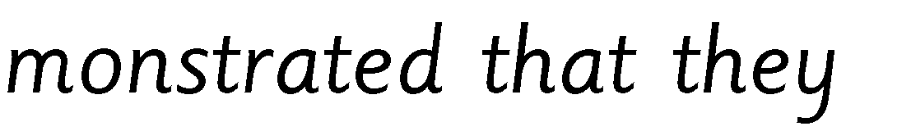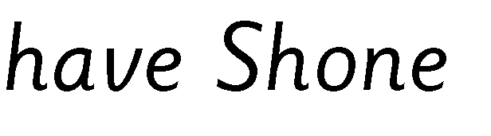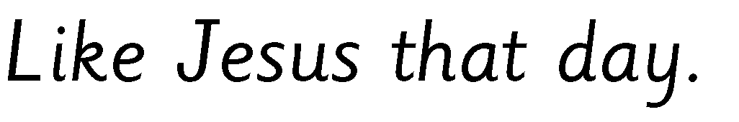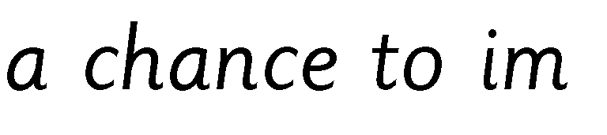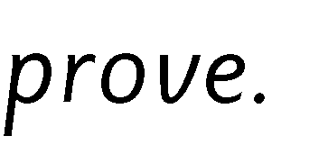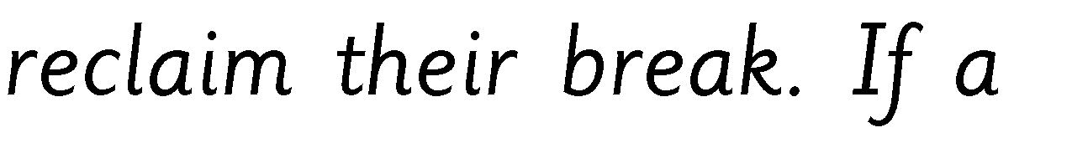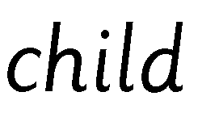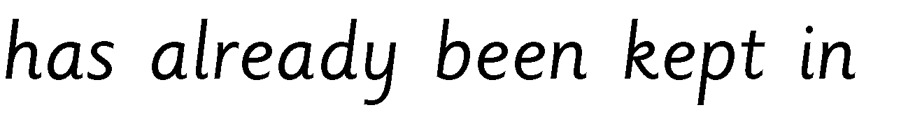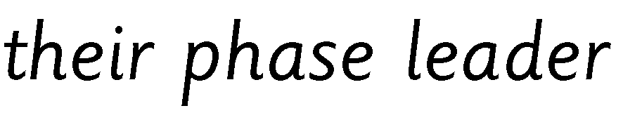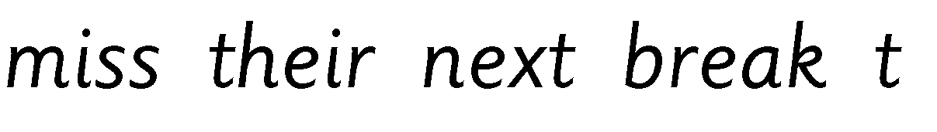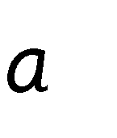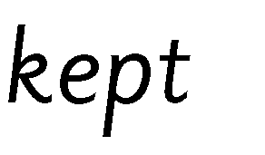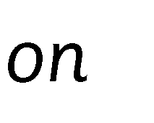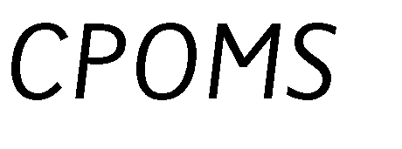

For misbehaviour during teaching time, a teacher would follow, “Have You Broken the Rules?” i.e.
- You will be given a verbal warning
- Shine Like Jesus system will be used
- You will be sent out for ‘Time Out’
- You will be sent to a member of the Senior Leadership Team

Being sent to a senior member of staff during lesson time constitutes a removal from lessons. Such a removal from lessons will be used to establish the circumstances of any incidents and to work with those involved to resolve the situation and prevent a recurrence. Any such removal will be for the minimum amount of time required for those involved to both become calm enough to return to their class and to reflect on the circumstances around the incident so that return to the class is appropriate and can be undertaken safely.

At playtimes, the following may be used:

- Give the children a reminder about the rules and expected behaviour
- Warn the child of the sanction that will follow if the behaviour continues
- Child required to take ‘time out’ in a designated area
- For repeated misdemeanours or more serious issues the child will be sent to the appropriate member of the Senior Leadership Team.

At any point in either of the above processes, teachers may wish to involve parents so that they have an opportunity to come into school to discuss concerns and agree future actions.

Serious misconduct will always be referred to the Head of school or, in their absence, to the Assistant Head. In these circumstances, parents will be consulted and liaison will take place, in order to seek a way forward.

Staff may wish to use other sanctions as appropriate e.g.:
- Loss of privilege e.g. playtime, time in adventure play area, attendance at a club
- Reflective work related to incident or misdemeanour
- Withdrawal from school trips that are not essential
- Sanctions related to the misdemeanour e.g. cleaning graffiti off a table

During Off Site School Trips children who do not behave in accordance with the behaviour agreement that forms parental consent to such trips may be sanctioned by, for example:
- Placing under the direct supervision of the trip leader (teacher)
- Withdrawal from part/ all of the activities involved in the trip
- Removal from the trip and return to school (where appropriate and feasible)

Exclusion
In rare cases it may be necessary to exclude a child. In this eventuality, the school will follow the statutory guidance on exclusion from the Department for Education.

Lunchtimes

The lunchtime supervisors are encouraged to build positive relationships with classes by offering a variety of different rewards and using strategies for good behaviour. Where poor behaviour occurs they are encouraged to hear both sides and deal with the specific behaviour, reporting back to the class teacher as appropriate. Please refer to the Guidance Notes for Lunchtime Supervisors.

Record keeping

Records are kept in school of both rewards and achievements and behaviour incidents that were referred to another teacher or member of senior staff.

- Rewards are recorded in such places as assembly, Star Awards given in Good Work Assemblies, stickers in children’s books. Children are also often given certificates in whole school and key stage assemblies for activities held both in and out of school.

- Sanctions given by the teacher that go beyond minor incidents should be recorded by the teacher on CPOMS as a Behaviour Incident. Create the log and title the concern ‘BEHAVIOUR: [detail]’ to distinguish it from other concerns that may be active. If a child has reached this stage they will have been sent to a senior member of staff/ the Head of School/ Asistant Head so they should be noted as the action taken.

- Other forms of monitoring behaviour in school are used in an age-appropriate manner and might include behaviour sticker charts and behaviour reports.

Searching pupils

The head of school and teaching staff may search a pupil, with their consent, for any item that is banned by the school rules, and in any situation considered necessary for the safety of pupils. This may include items such as mobile phones.

Consent is not required if the search is for knives or weapons, alcohol, illegal drugs, stolen items, tobacco, fireworks, pornographic images or articles that they reasonably suspect have been or are likely to be used to commit an offence or cause harm.

For further information, see the Physical Contact Including the Use of Reasonable Force Policy.

Use of reasonable force

Physical contact may be used by all members of the school staff to control, restrain or direct children without the use of force. Physical restraint (the positive use of force) may be used in order to protect a child from hurting her or himself or others, or from seriously damaging property. In all cases, members of staff are guided by the Physical Contact Including the Use of Reasonable Force Policy. The decision on whether or not to physically intervene is down to the professional judgement of the staff member concerned and should always depend on the individual circumstances.

Confiscation

Staff can impose any reasonable penalty including confiscation, retention or disposal of a pupil’s property. Confiscated property will be kept until it can be handed to a parent.

Beyond the school gate

In accordance with the DFE Behaviour and Discipline in Schools, the school has a statutory power to discipline pupils for misbehaving outside of school premises “to such extent as is reasonable”. At St Anthony’s this includes misbehaviour when the pupil is: • Taking part in any school organised or related activity.
- Travelling to or from school in school uniform or in some other way identifiable as a pupil from St Anthony’s Primary School.
- In extreme cases (e.g. cyber bullying), misbehaviour at any time which could have repercussions for the orderly running of the school.
- Posing a threat to another pupil or member of the public.
- Behaving in a manner which could adversely affect the reputation of the school.

Reasonable responses to instances such as this may include:
- Notifying a parent immediately
- Notifying a senior member of staff
- Logging details of the incident and pupil(s) involved and passing to a senior member of staff as soon as practically possible
- Notifying/ calling the Police

Support Systems

Internal support systems for individual pupils exhibiting behaviour that does not meet our expected standards may include:

- Use of a daily weekly behaviour chart
- and reward system
- Contact with and regular feedback to parents
- Individual interventions
The use of external services
- Intervention provision in school time aimed at social skills/ behaviour awareness
Occasionally outside help is needed and we are able to call on appropriate external agencies for further advice and guidance.

Continuing Staff Development

All staff should participate in ongoing continuing professional development including the attendance at courses, talks and meetings. Behaviour should be a regular item on the agenda of staff meetings and Key Stage meetings when concerns and policy should be discussed. All new staff should be made aware of the school’s values, and Behaviour policy. Regular monitoring and evaluation should occur as indicated in the School Improvement Plan.

Staff seeking support and development beyond this should approach their line manager.

Allegations

If an allegation is made against a member of staff the procedure in the ‘Managing
Allegations against Employees’ policy will be followed. As part of this we will ensure the availability of regular ongoing communication and support to the employee both through external support (e.g. Occupational Health, Employee Assistance Programme) and regular review both during and after any investigation. Support will be balanced and take account of the particular nature of the allegation and the needs of the employee. It may well also be necessary to ensure consideration of the provision of ongoing support to the child or young person who is the centre of the allegation.

Transition

Between classes/ key stages:
- Handover sheet between class teachers concerned in July
- Record of formal rewards areas of strength and achievement)
- Access to behaviour notes/ charts/ behaviour logs
- those kept by the class teacher where appropriate, including strategies deployed for managing poor behaviour if appropriate
- This information is shared with all adults working with pupils of concern at the beginning of the following academic year
- Children with specific needs might be supported by a TA/ transition sessions or materials and other outside agencies they may already be working with

For children leaving our school setting (including Year 6 to 7 transition):

- Transfer of pupil data to new setting and responses to any requests for information from the receiving school as appropriate
- Contact/ discussion/ references written by Year 6 teacher for Head of Year as requested
- SENCO meets with or contacts the SENCO at the destination school to discuss children with specific needs. This may also involve other outside agencies the child may already be working with

For children arriving at St Anthony’s:

- Transfer of pupil data from old setting and subsequent requests for information as appropriate
- All children arriving will be assigned a pupil buddy who helps orientate them with times, places and routines.
- Children with specific needs may be assigned a TA/ other adult to support them. The SENCO meets with parents of children with specific needs either shortly before or after the child comes on roll.

All children are re-familiarised with the Behaviour Policy and the expectations at the beginning of the academic year.

How We Approach Bullying – Anti-Bullying Policy

Statement of Intent
We are committed to providing a caring, friendly and safe environment for all of our children so they can learn in a relaxed and secure atmosphere. There are two components in effective anti-bullying practice: prevention and reaction. We regularly discuss and consistently condemn bullying so that all staff and children are alert to signs that bullying is (or might be) taking place and are encouraged to report any incidents or concerns. Bullying of any kind is unacceptable at our school. If bullying does occur, all pupils should be able to tell and know that incidents will be dealt with promptly and effectively. We are a TELLING school. This means that anyone who knows that bullying is happening is expected to tell the staff. Pupils and parents will be assured that they will be supported when bullying is reported.

What Is Bullying?
Bullying is:

Behaviour by an individual or a group, usually repeated over time, that intentionally hurts another individual or group either physically or emotionally.

Bullying may be prejudice-based and/or discriminatory and might involve behaviour such as:-

Emotional | being unfriendly, excluding, tormenting (e.g. hiding books, threatening gestures)
Physical | pushing, kicking, hitting, punching or any use of violence
Racist | racial taunts, graffiti, gestures
Sexual | unwanted physical contact or sexually abusive comments
Homophobic | because of, or focussing on the issue of sexuality
Verbal | name-calling, sarcasm, spreading rumours, teasing
Cyber | misuse of new technologies – sending spiteful texts on mobile phones, sending hurtful messages by email

In our school bullying does not include:
- One off aggressive acts on the spur of the moment
- Retaliation
- Accidental hurt caused through thoughtless acts or words

Signs and Symptoms
Although a child who shows one or more of these indicators is not necessarily being bullied but may be distressed for other reasons, children who are being bullied often display a variety of the following. Although this is not intended to be used as a checklist, adults should be aware of these possible signs and discuss them with staff if they are concerned:
- is frightened or unwilling to come to school
- becomes withdrawn anxious, or lacking in confidence
- cries themselves to sleep at night or has nightmares
- frequently feels ill in the morning
- begins to under-perform in school work
- comes home with clothes torn or books damaged
- has possessions go "missing"
- has unexplained cuts or bruises
- displays personality changes
- is frightened to say what's wrong

Why is it Important to Respond to Bullying?
Bullying hurts and no one deserves to be a victim of bullying. Everybody has the right to be treated with respect. Pupils who are bullying need to learn different ways of behaving.

We have a responsibility to respond promptly and effectively to issues of bullying.

Anti-bully displays are in every classroom and are displayed around school and are referred to in the different activities undertaken in the classroom to reinforce the message that bullying type behaviours are unacceptable, in or out of school.

Procedures
- Allegations of bullying will be taken seriously and should be reported to the child’s class teacher
- The bullying behaviour or threats of bullying must be investigated and appropriate intervention taken – see Action Flow Chart (Appendix 1) and Children’s Incident Record (Appendix
2)
- Where an incident is referred to the class teacher a log should be entered into CPOMS that covers all children involved. Please alert a senior member of staff.

Outcomes
- The child who has been bullied is supported.
- Anyone who bullies will be made aware of the consequences of their actions. It should be made clear to them that they are bullying and that their behaviour is unacceptable. The consequences that may take place are: the bully (bullies) will be asked to genuinely apologise, the bully may lose privileges, or in serious cases exclusion will be considered.
- If possible, the pupils will be reconciled.
- After the incident / incidents have been investigated and dealt with, each case will be monitored by the class teacher or other named adult to ensure repeated bullying does not take place.
- An attempt will always be made to help the bully (bullies) change their behaviour. Pupils who bully may also need help and we have a responsibility to ensure we offer appropriate support so that those who bully can empathise with and relate more constructively to others
- Access the services of other professionals, should the situation warrant it.

Prevention
We will use a range of methods for helping children to prevent bullying. These may include:
- Using circle time and school assemblies as a regular forum to remind all children that bullying is not tolerated in school. Everyone has the responsibility to tell someone if they witness any incidents of bullying.
- Agreeing and writing a set of school/class rules
- Use opportunities in the curriculum to explore issues around bullying
- Implementing the Life to the full plus PSHE curriculum and materials so that we explicitly promote social, emotional and behavioural skills
- Building on friendship networks through interventions or the use of external services.
- Listening attentively to our pupils’ concerns or complaints so that problems do not escalate. Children should feel that their views will be listened to, taken seriously and acted upon if appropriate
- Developing a range of peer support systems that can be utilised • Providing professional development

child on child abuse

Children who abuse other children

Children and young people who abuse others, including those who sexually abuse/offend, are often likely to have considerable needs themselves. They may pose a significant risk of harm to other children. They may have suffered considerable disruption in their lives, been exposed to violence within the family, may have witnessed or been subject to physical or sexual abuse, have problems in their educational development, and may have committed other offences. Such children and young people are likely to be children in need, and some will in addition be suffering or at risk of significant harm, and may themselves be in need of protection. Children and young people who abuse others should be held responsible for their abusive behaviour, whilst being identified and responded to in a way which meets their needs as well as protecting others.

In such cases, the needs of such children should be considered separately to the needs of their victims. Consideration needs to be given to the fact that these children may have considerable unmet developmental needs as well as specific needs arising from their behaviour.

Please refer to the Child Protection policy for further information.

Monitoring and Evaluating the Policy

This policy will be subject to on-going monitoring and evaluation, with staff INSET and termly reports to the Governing Body as appropriate.

Communication

All staff, including supply staff, will receive a copy of the policy. A summary will be published in the school prospectus and the full policy will be published on the school website and available from the school office.

Policy revised Autumn term 2024
Approved by Governors
Review date 2025

Action Flow Chart Appendix 1



